**16 BIT SUBTRACTION**

**EXPERIMENT 6**

**AIM:** To write an assembly language program to implement 16-bit subtraction using 8085 processor.

**Algorithm:**

1. Get the LSB in L register and MSB in H register of 16 Bit number.
2. Exchange the content of HL register with DE register.
3. Again Get the LSB in L register and MSB in H register of 16 Bit number.
4. Subtract the content of L register from the content of E register.
5. Subtract the content of H register from the content of D register and borrow from previous step.
6. Store the result in memory location.

**PROGRAM:**

LHLD 2050

XCHG

LHLD 2052

MVI C,00

MOV A,E

SUB L

STA 2054

MOV A,D

SUB H

STA 2055

HLT

**INPUT:**

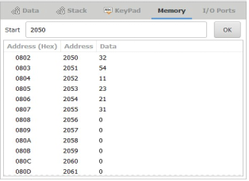

**OUTPUT:**

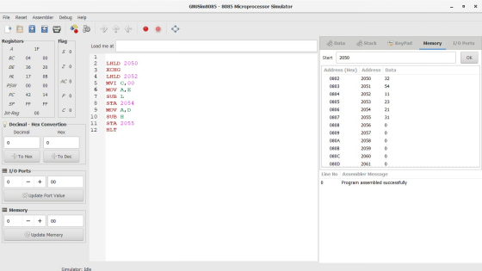

**RESULT:** Thus the program was executed successfully using 8085 processor simulator.